DESCRIPTION OF THE PROJECT

This project is designed for hotel reception staff and customers who want to create reservations.This project will enable hotel receptionists and customers to make new room reservations. Thanks to this project, the availability of the rooms will be visible and the information and payments of the customers who have made a reservation will be recorded.

USE CASE DIAGRAMS

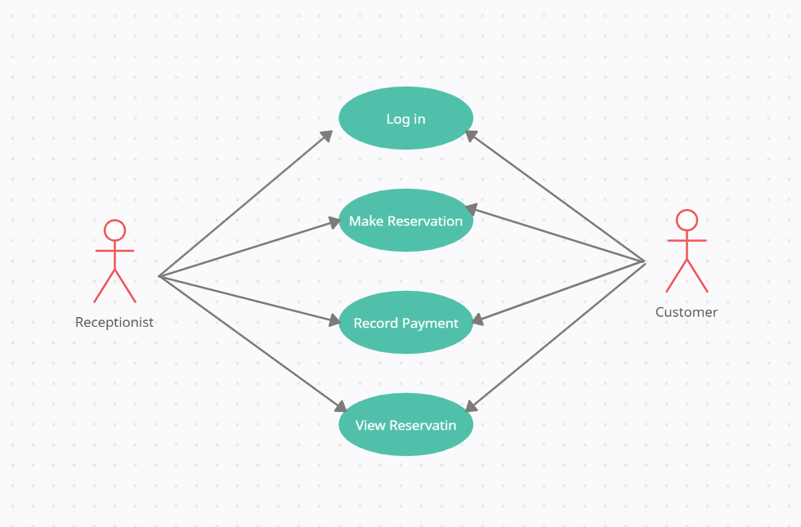

INTERFACES

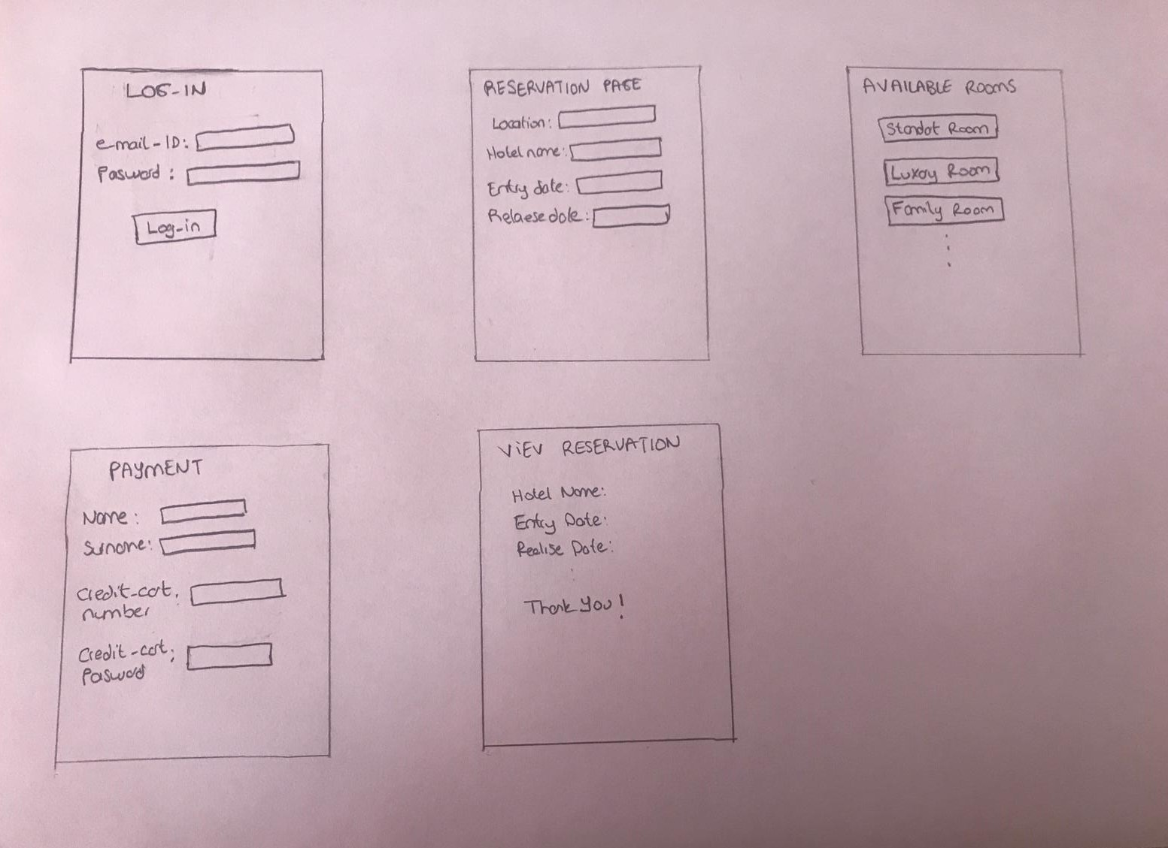

DATABASE ER DIAGRAM DESING

